Crocodile Dentist  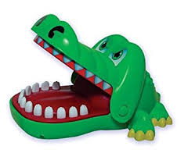  Basic to intermediate level  Ages: | Pieces included in visuals  Rules for game  - Each student playing takes turn passing the crocodile back and forth pushing down a tooth one at a time  - Peers can use the visual “Did it bite you?”  - Student reply either “Yes/No”  - Continue to play, each person pressing a tooth down one at a time until the crocodile’s mouth closes  Additional Tips and Ideas  - Set a timer and keep playing until the timer goes off  - Have student express how they feel about the game

